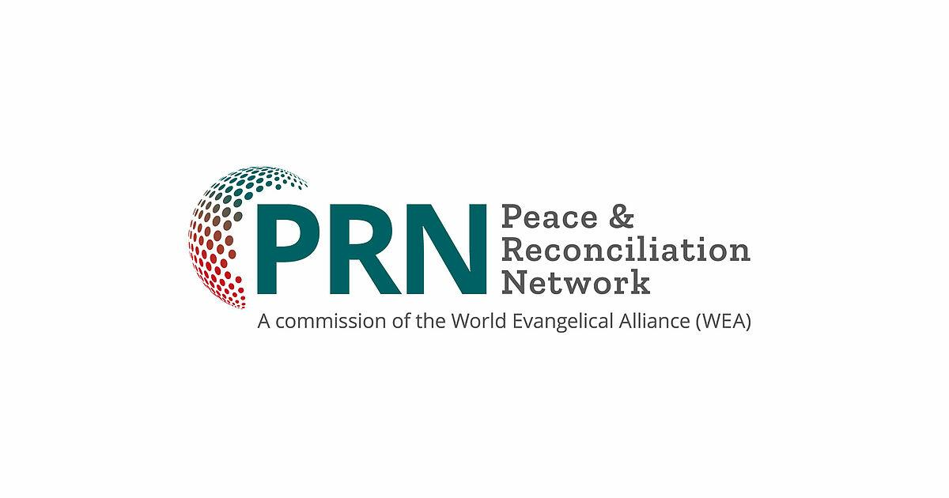
CHURCH AND PEACE IN AFRICA
INTRODUCTION
From pre-colonial times to our current modern era, the African continent has witnessed several forms of atrocities. More specifically, since the end of the Second World War, Africa has become the most affected region in the world by conflicts, particularly among non-state groups. These conflicts have, in some countries, exposed the failure of state institutions, while in others, they have resulted in a high number of refugees and internally displaced communities within these countries. Additionally, many people have migrated to other countries in search of a better source of livelihood.
Today, throughout Africa, several communities continue to suffer under internal/intercultural and religious tensions, political discords, injustice and the abuse of power. These ethnic conflicts are the root causes of several conflicts and civil wars.
The church, a community of believers in Jesus Christ and, to paraphrase St Paul in his letter to the Ephesians, “…the people whom God has chosen and adopted, to whom God has granted a share of inheritance with Jesus Christ, and that He marked with His seal by the Holy Spirit…”, has experienced and continues to experience division to the extent that Christians are unable to commune in the same buildings. In some places in Africa, especially within the Evangelical Church, the church fallen prey to the forces of ethnicity.
In fact, we assert that today, more than before, and even more so than four or five centuries ago when the first Christian missionaries set foot on African soil, the world is troubled and the human race is in distress.

A Troubled World and Humanity in Distress
The trouble plaguing our world and the distress of humanity are evident through the growing poverty and inequalities afflicting it, the increasing difficulties faced by human communities in accessing essential natural resources for their survival, religious intolerance, violations of human rights and all the tensions and conflicts stemming from democracy and governance in African States and communities.

Poverty and Inequality

Poverty and conflicts are closely intertwined. Poverty and inequalities are the driving forces behind civil wars and armed conflicts, which in turn, lead to poor governance and weaker economic performance.

Difficult Access to Natural Resources for African Communities

The African continent is endowed with natural resources including diamonds, gold, petroleum, natural gas, uranium, brass, platinum, cobalt and many more. Nonetheless, challenges in accessing these natural resources and controlling the revenues generated from them remain significant drivers of conflicts and violence in Africa. This link between natural resources and conflicts has been observed throughout human history. Just as animal species fight violently for scarce resources, so do humans fight for essential resources that are often distributed unjustly and unfairly.

Cultural and Religious Tensions

Three types of religious conflicts are currently observed in Africa:

- Inter-religious conflicts, primarily between Christians and Muslims.

- Conflicts among people of the same religion (Catholics versus Protestants, Fundamental Protestants versus Charismatic renewal ideologists, Churches founded by missionaries versus churches founded by Africans).

- Religious conflicts with political connotations.
In summary, we witness numerous conflicts resulting from globalisation and are resultant of tensions within and between cultures.

Violations of Human Rights
Insurrections, domestic conflicts and inter-communal violence are the primary drivers of human rights violations, leading to war crimes against humanity, including attacks on property, freedom and human dignity.

Power Struggles and Exclusion Policies

Societies are drifting apart and leaning towards protectionist nationalism and politics. Conducting general elections, often amidst armed conflict, has become a widely discussed exercise in Africa. This is marked by the determination to protect economic and political interests at any cost, resulting in the erosion of democratic norms and the authorization of wars. Some leaders attempt to evade term limits, rig elections and limit electoral candidates to same ethnic or family backgrounds. External actors also interfere in electoral processes to shape the outcomes.

THE MISSION AND MANDATE OF THE CHURCH IN A TROUBLED AND DISTRESSED WORLD
International institutions and organisations involved in search for solutions to conflicts often perceive the Christian faith as one of the sources of conflicts and exclude it as a potential solution to conflict.
Unfortunately, many Christian communities, especially Evangelical ones, voluntarily exclude themselves from the circle of conflict resolution actors in the world. They base their decisions on Bible passages and slogans such as “we don’t involve in politics”. Some theological justifications for this stance reference some of the following Biblical texts:
- “Give back to Caesar what is Caesar’s and to God what is God’s.” Mark 12:17

- “Let everyone be subject to the governing authorities, for there is no authority except that which God has established. The authorities that exist have been established by God…” Romans 13:1-2

- “…Jesus answered Pilate: “My kingdom is not of this world. If it were, my servants would fight to prevent my arrest by the Jewish leaders. But now my kingdom is from another place.” John 18:36
The Godhead in whom we believe, the Creator of the heavens and the earth, Jesus Christ the redemptive Son and the Holy Spirit, the Comforter and Renewer, unite us in His church to accomplish one mission: Be His image and restore to Him the human race and all of creation which groans deeply of the pains of childbirth.
Is the mission of the church, as a messenger and prophet of God, limited solely to preaching forgiveness of sin and eternal life? Does it not also encompass bringing the Good News to the poor of this world who lack access to essential natural resources in their territories? Is it not about healing those with broken hearts stemming from violence and violations of human rights, particularly refugees who have lost their homes, jobs and livelihoods for themselves and their offspring? Is it not about taking concrete initiatives that allow them to tell the deported: “You are free!” and to those in prison “You will see the light of day again!”?
In the 21st century, has the Church not also received the mandate of Joseph, who was established as master over all Egypt to save the lives of a numerous people?” Or the mandate of Moses, the liberator who made use of the word to tell Pharaoh: “Let my people go so they can serve me” Or the mandate of Esther and Mordechai, who thwarted and denounced political assassination plots and projects of genocide?
Shouldn’t the Church, in our opinion, take on the mantle of Nehemiah to commit our fellow citizens to the rebuilding of the moral and cultural pillars of our cities and villages which have been demolished by corruption, drug abuse by the youth, homosexuality and other forms of moral depravity encouraged by some political, financial, national and international institutions? The church of Jesus Christ is part of messianic history, preceded and surrounded by the great cloud of witnesses, including Gideon, Barak, Samson, Jephthah and David, to mention but a few, who by faith, conquered kingdoms and exercised justice? Were their fasting and prayers not followed by words, actions and concrete commitments in their generations?
The Association of Evangelicals believes that there are between 150 to 180 million evangelicals in Africa. This is an impressive number and it presents opportunities for the transformation of Africa. Evangelicals have the potential to bring healing to various situations of conflict.
It would be of little use for the Church, ambassador in the name of Jesus Christ, to only preach reconciliation with God, the forgiveness of sins to all without demonstrating the faith she proclaims. Indeed, as James proclaims, “Suppose you see a brother or sister who has no food or clothing, and you say, “Good-bye and have a good day; stay warm and eat well”—but then you don’t give that person any food or clothing. What good does that do?”
To distraught disciples facing a crowd of thousands of people in a deserted place and at a late hour, our Lord made a recommendation that is still valid for our current world: “Notre Seigneur a fait une recommendation qui demeure actuelle pour notre monde trouble” (“You give them something to eat.”) In other words, give to drink to those who are thirsty, welcome strangers, clothe the naked, visit the sick and those in prison. In a sentence, THE EVANGELICAL CHURCH IN AFRICA MUST REALIZE ITS CAPACITIES AND ITS SPIRITUAL RESOURCES TO BE AN AGENT OF CHANGE FOR PEACE AND RECONCILIATION AT THE COMMUNITY AND NATIONAL LEVELS.

Dr Desmond Tutu, Anglican Archbishop, Emblematic Figure of the Struggle against Apartheid in South Africa, said this: “If you are neutral in situations of injustice, you have chosen the side of the oppressor. If an elephant has its foot on the tail of a mouse and you say that you are neutral, the mouse will not appreciate your neutrality”.

